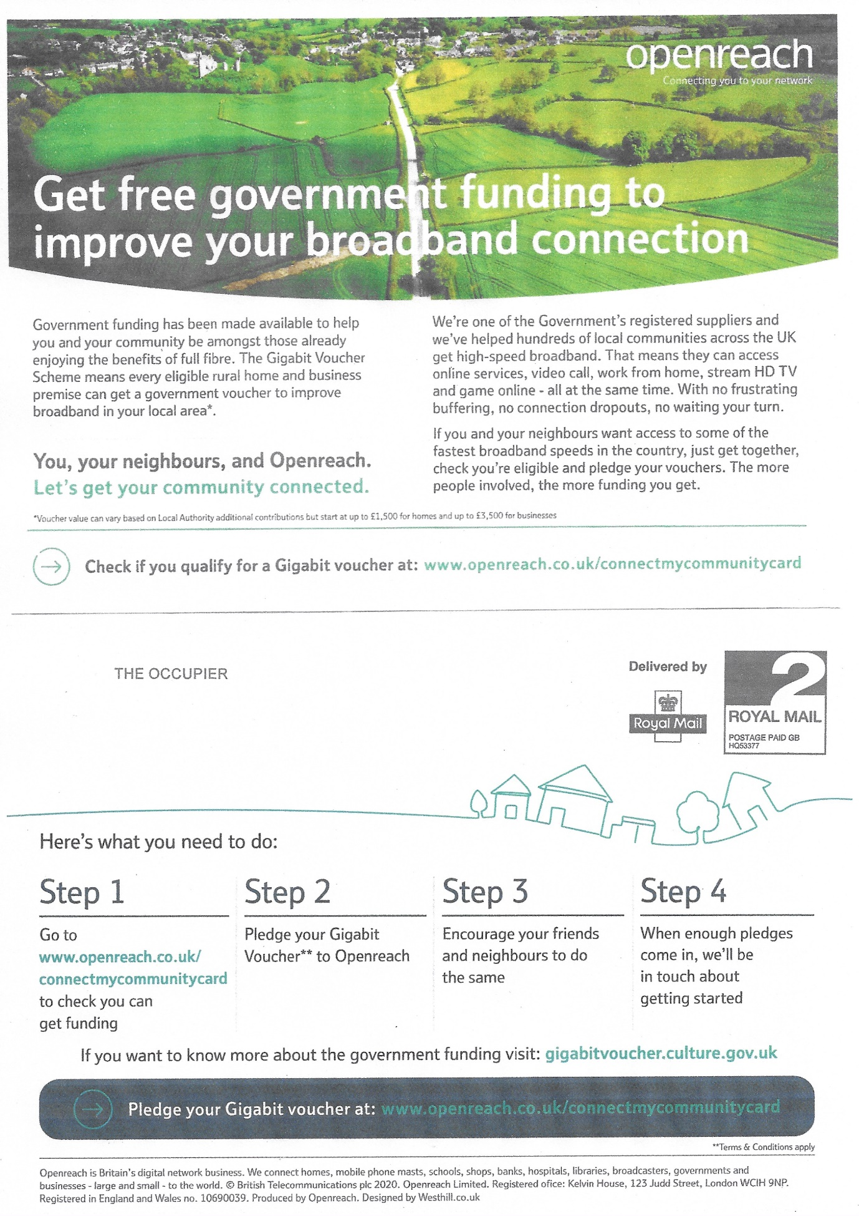

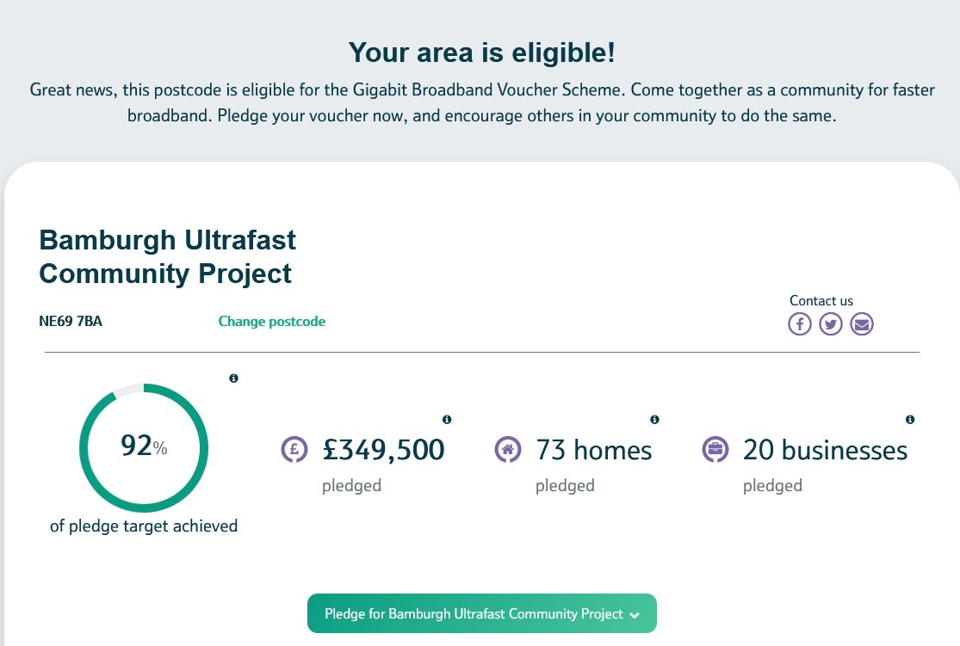

Almost there …..!

Bamburgh Parish Council urges you to pledge to enable this community project to be implemented for the benefit of all.

